Parametric Design In Fusion

Sometimes when designing objects, dimensions of certain things need to be in relation with others. Let’s say that we’re making a rectangular prism and we want the width to be twice the height. Sure, you could just dimension it so that the width is twice the height, but sometimes this is impractical and ridiculously tedious, and that’s where **Parametric Design** comes in. The definition of a parameter is: ”a quantity whose value is selected for the particular circumstances and in relation to which other variable quantities may be expressed”, and that basically means that a parameter is a variable that decides the value of other variables (eg x is the parameter, and decides the value of y with the relation of y = 4x). This tutorial will go through the fundamentals of using parameters in Fusion.

Step 1: define your parameters

In the “modify” dropdown list , you’re going to want to click “change parameters”

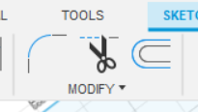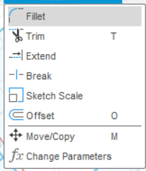

After clicking the option, you should be at a table that looks like this:

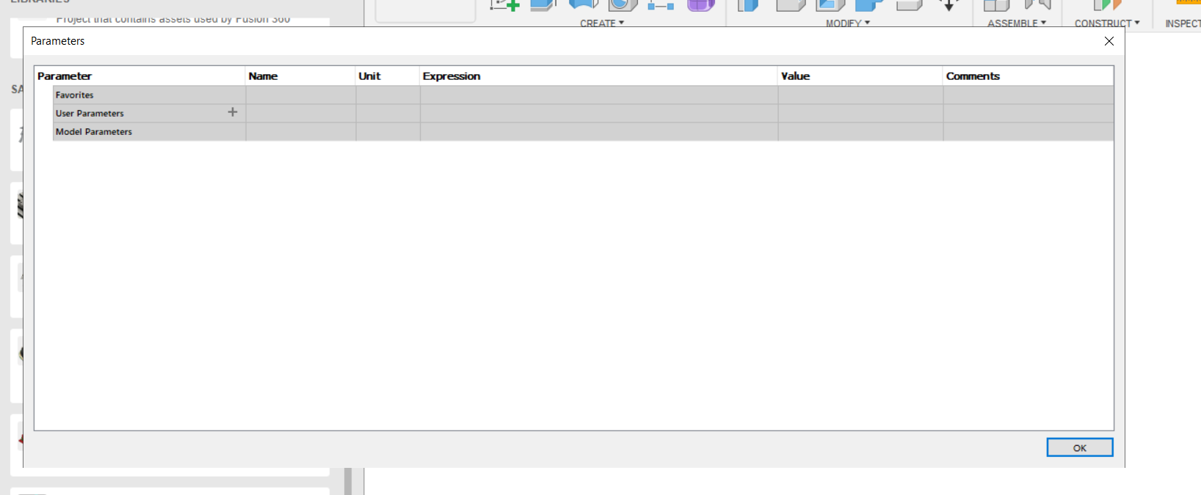

Here, you can see 3 options: Favorites, User Parameters, and Model Parameters. Model Parameters are the parameters that Fusion creates to create your design, so you’re going to want to create a new User Parameter by clicking on the plus sign in the “User Parameter” box.

Next, you should be at a popup that looks like this:

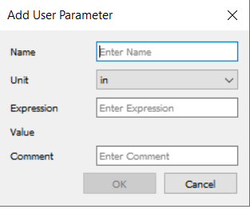

Name your variable appropriately with correct naming conventions, as confusing names will only be a hindrance later on. Most of the time, you’re going to be using Inches, but if you’re feeling extra zesty, you can change the units to whatever you’d like. The important part, however, is the “Expression” Text Field. This is where you can enter in the value or the expression you’d like the parameter to represent. It could be something simple, like 2.00 inches or 4.00 cm, but you can also use expressions. How? Well, lets create a parameter called “Width” that holds a value of 4.00 inches.



Next, let’s create another parameter called height, and let's say we want it to be 3 times the width plus 5 inches. We can actually use the Width parameter we created earlier to represent the width in the expression, and doing so would result in this:

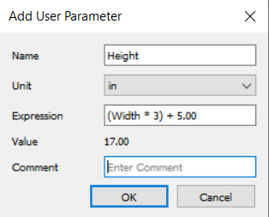

(Note: remember to use parentheses to make sure that you get the value you want)

As you can see, we set the value of Height to thrice the WIdth value plus 5.00, and since we set the value of Width to 2.00 earlier on, the value of Height will simple be (2*3)+5, and as it says in the “Value” field, Height is 17.00 inches.

As you can see, creating variables and parametric dimensions becomes amazingly easy with the Parameter Tool:

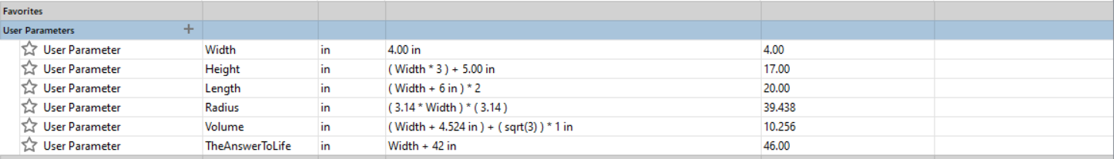

Rather than manually calculating the value of each dimension, and needing to change each individual dimension if we wanted to change the dimension of width, we can simply resize our design by editing the Width parameter, and that will automatically change the value of all other parameters accordingly. So, how do you implement these parameters?

Firstly, let’s create a simple sketch of a rectangular prism. Firstly, we create the base, and we want to set one of its sides to Width. Firstly, we should set some constraints ( outlines here:

[0 - Fusion Reference Sheet - Google Docs](https://docs.google.com/document/d/1NfeJM0EGV2tJlRY_ieRJ7goC8rM3cQQND8p_XY_7FUY/edit) ). We set the side opposite to the side we want to edit to be equal.

Then, we right click the side to be edited, and click the “Dimension” value. When we edit the dimension, instead of typing in a number, we type in the name of the width parameter, “Width”.

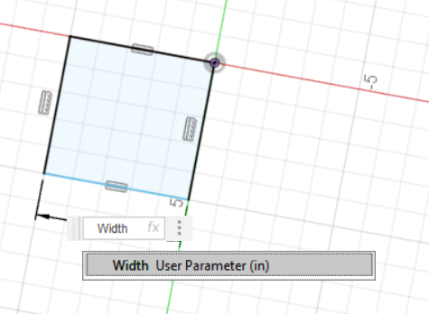

You can assure yourself that it worked by looking at the “fx” in the box. Hit enter, and you’re done! You’ve successfully defined a dimension to be a parameter. With a couple of more dimensions, you can make yourself a nice little prism:

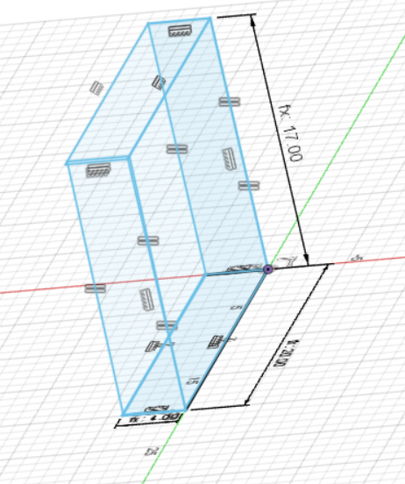

And voila! We’ve created our own little mini cereal box rectangular prism using parameters!

Documentation of creating expressions:  
Square Root - sqrt(x)

ab - a^b or (a)^b

π - create another parameter called “pi” that holds a decimal value of pi:

